Happisburgh - The village falling into the sea
Alan D Horn 515733
Photography 3

Activity Blog

June 2019

Analysis of my topic options
1 Tribes – are they now really just tourist attractions
2 Animals in captivity – are they really a part of a worldwide programme for protective breeding or are they exploited?
3 Disability and the mental and physical barriers
4 landfill – what is underneath. Why are the companies so secretive?
5 care in the community – what does it really mean?
6 Homelessness
7 My cancer treatment
8 Coastal Erosion

10 June
Discussion with Robert Enoch, Tutor, Contextual Studies
25 June
Discussion with Andy Hughes, Tutor, Body of Work

27 July
Decided on Coastal Erosion in Norfolk

Contacted Norwich City Council
Contacted Gt Yarmouth Town Council
Contacted Cromer Town Council
Contacted Hunstanton Town Council

Worrying that the service levels for all of these are rated as abysmal! Nevertheless, I got a name –
Darren Barker who pointed me towards Brian Farrow at North Norfolk District Council (NNDC).

11 Aug
Trip to Weybourne and Kelling Hard to photograph the cliff erosion and the beach
recovery work.

12 Aug
BBC Look East Inside Out. David Whitely programme on erosion in Norfolk and why UK does little to
protect coastal communities whereas Holland spends €400m p.a. on its sea defences and plans to do so through to 2050. "The Dutch don't understand why we don't protect our citizens"
Sandscaping at Bacton (which is 5 miles from Happisburgh) will give 15-20 years protection to the gas terminal and the village.

Sept
Decided to focus on Happisburgh as my project

Oct 9
First phone contact with Brian Farrow, Coastal Engineer, North Norfolk District Council (NNDC). Very positive feedback and linked me to Malcolm Kerby of Coastal Concern Action Group (CCAG) who is a Happisburgh resident.

October 10 – 15
Messaged Happisburgh Parish Councillors and had positive exchange with Denise Burke and we will meet
Messaged local vicar of Grade I listed, St. Mary's church, Catherine Dobson – not interested and unhelpful.
Messaged Malcom Kerby – very positive and we will meet in a week or so
Messaged Tim Bristow, East Anglian Daily News – a waste of time
Messaged Mike Page, ariel photographer of Happisburgh erosion over last 15 years. He kindly agreed to allow me to use his images providing I credit him.

11 Nov
Happisburgh meetings – separate as Denise and Malcolm "do not see eye to eye".
Denise and husband Stephen bought their Grade II listed cottage in 2010 when the erosion was not a major issue and the Shoreline Management Plans were in place. They were sure that the area was protected and that the house was safe "until the next century".The storms of 2013 caused massive cliff falls which created a double whammy to Denise and Stephen. The field between them and the sea lost about 50mtrs of cliff and many of the caravans in the site situated there were in danger falling into the sea. The erosion accelerated and the caravan park was relocated. Furthermore, the cliffs below are designated as a Site of Special scientific Interest (SSSI) and cannot be protected.
Denise gave me a lead to Bryony Neirop-Reading who lives close to the cliff edge, as someone I must talk to.

Malcolm Kerby is the driver of the Pathfinder scheme that secured funding for residents whose properties in Beach Road were to be demolished as the cliffs were rapidly crumbling. He organised for both of us to meet Brian Farrow and agreed to me setting an agenda.

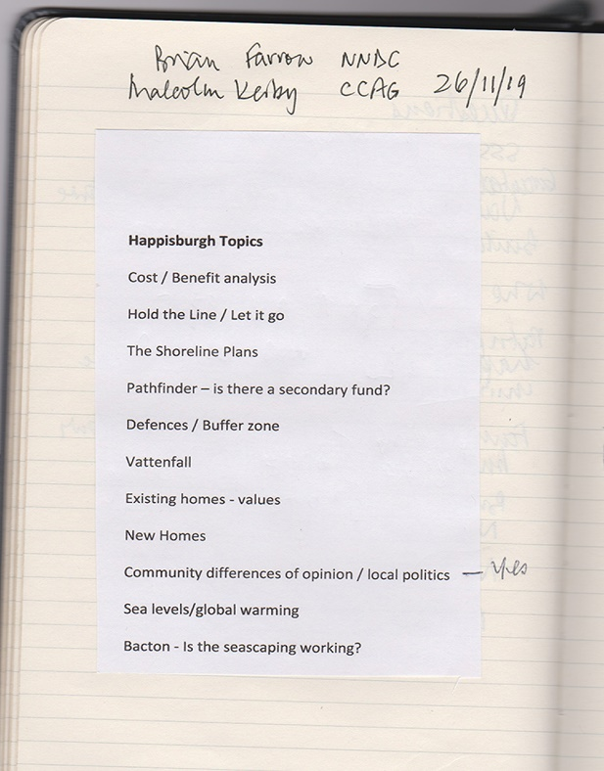

14 Nov
Saw cottage for sale next to Bryony and Nichola £190,000 – cash only as no mortgage available. Only bought a year ago. According to Nichola, couple realised it was a mistake. Sold it for £90,000. Couple divorced.

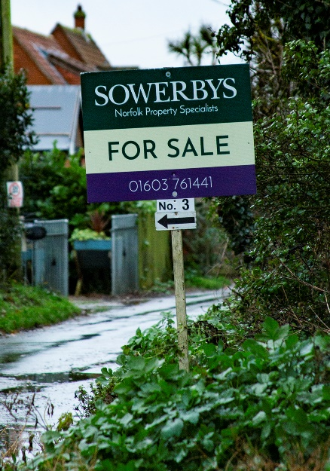

21 Nov
Natural England Lucy Hatcher email

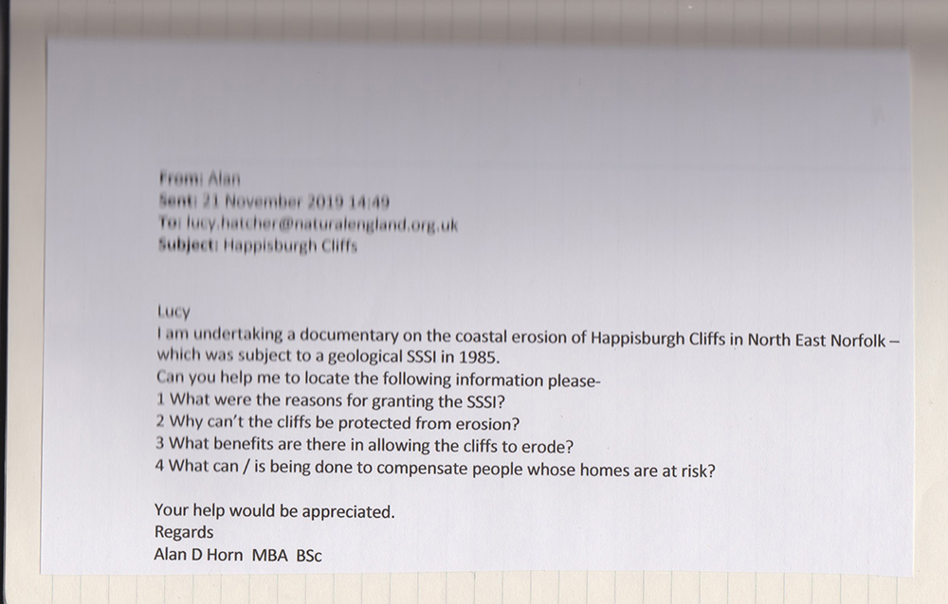

26 Nov
Meet Malcom and Brian in Happisburgh carpark. Brian great help and answers most of my questions –
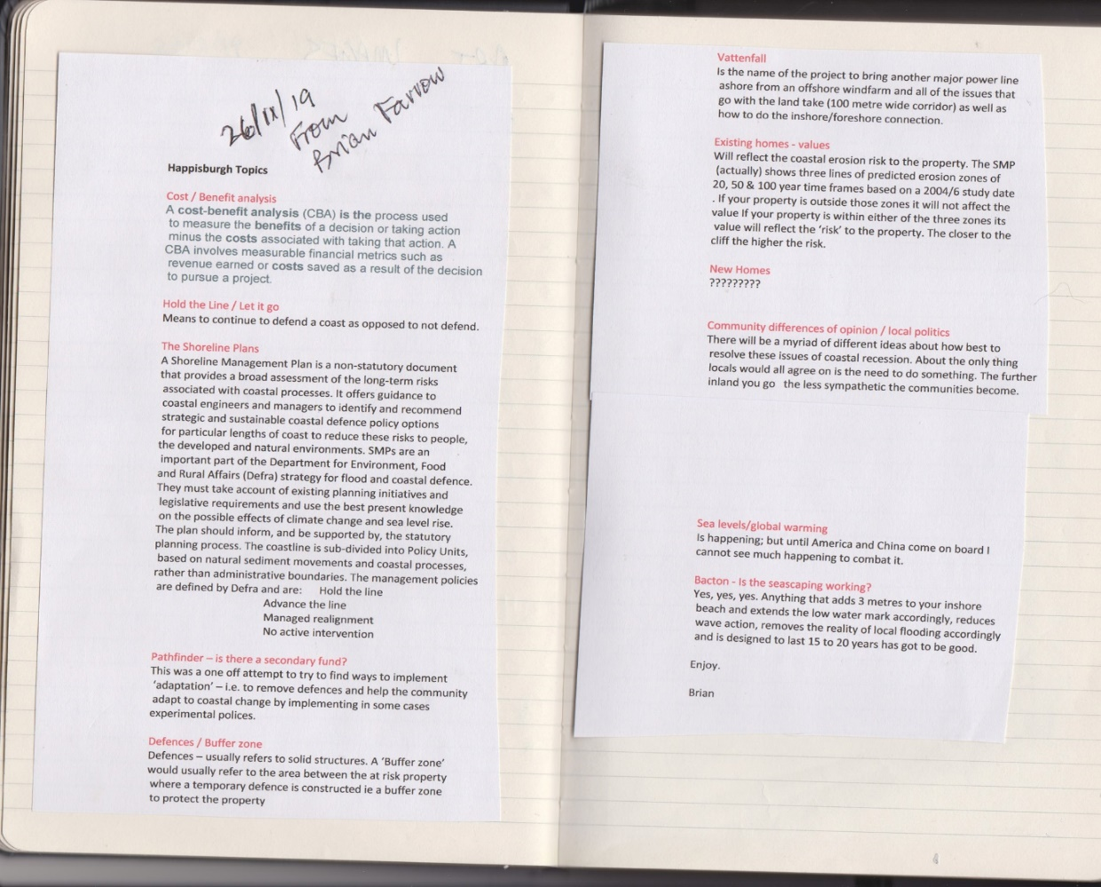

Brian also introduces me to Dr Alan Brampton, Principle Coastal Engineer for H R Wallingford.
26 Nov
Meet Bryony Neirop-Reading, known locally as "Queen Canute" as she lost her house in Beach Road in 2013 and then moved into another in Beach Road that is under threat. Her story included in BoW and CS final paper.

3 Dec
Contact Alan Brampton
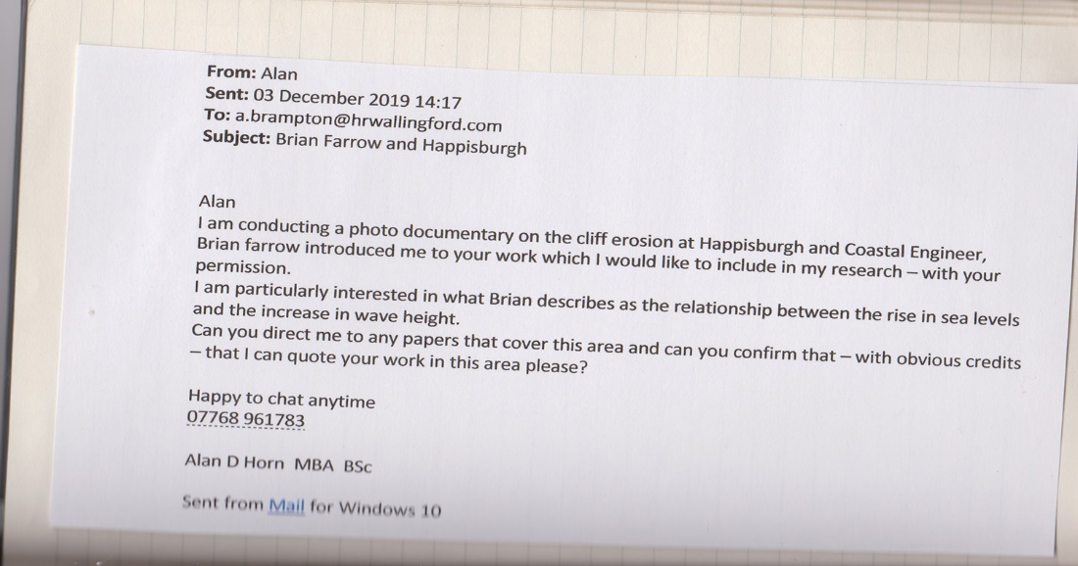

3 Dec

Passed to Emma Quick at Natural England who recommends key person Andrew Millar

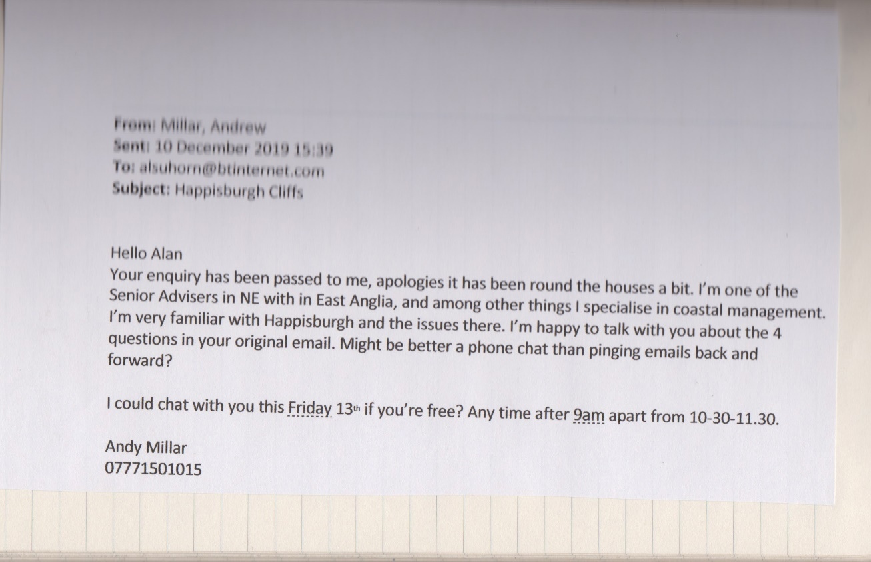

13 Dec
Telephone meet with Andrew Millar Natural England.
12 years as Senior Advisor in Coastal Management, Wash to Thames.
"It's all down to funding and if you protect one community others will suffer further down the shoreline drift and Gt Yarmouth cannot be compromised"
"Adaption is the only answer in moving the community but whole argument lost in corridors of government".
NNDC has represented the community well although many do not agree. They can only do so much without funding"
"Malcolm Kerby has brought a level of pragmatism to the situation although he is seen as "marmite".
He then makes a strange statement – "The beach now seems stable as sand martins are nesting in the cliffs". Clearly. No interest in the human community.

Dec 28
Visit with drone to capture differing and more dynamic images particularly those properties at risk especially Sue Haywards bungalow Seashell

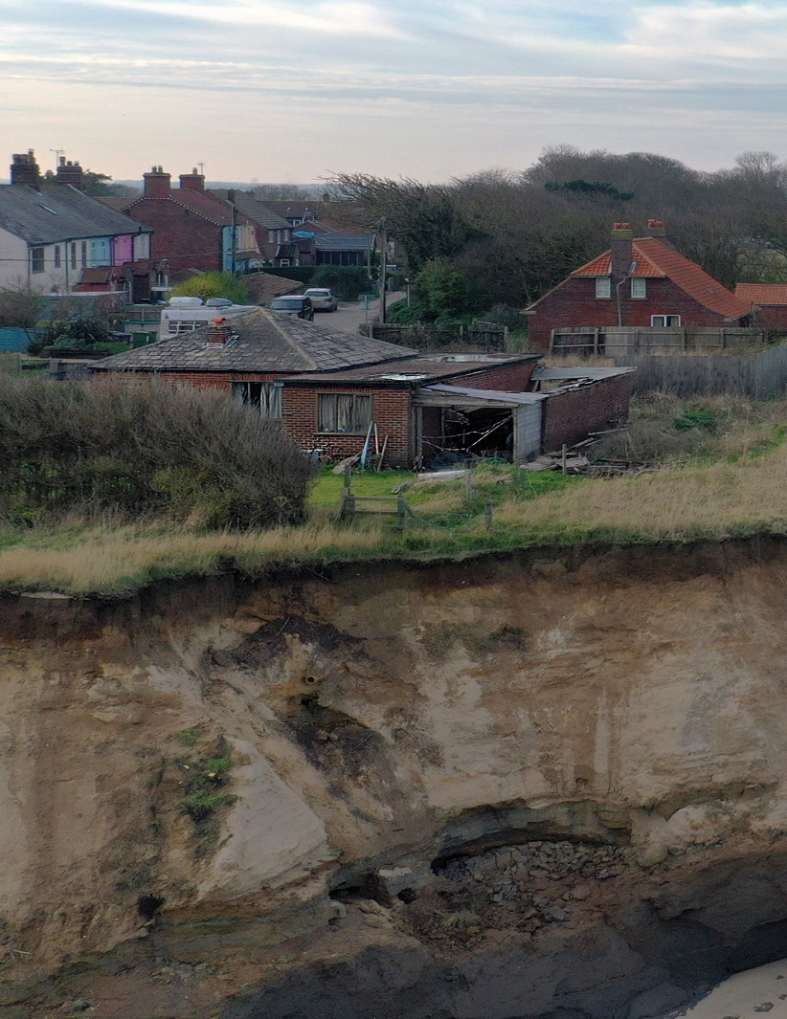

Feb 18 & 19 2020

Meeting community members
18th
Malcolm Kerby 11am
Bryony 1 pm
19th
Denise and Stephen Burke 12pm
Sue and Colin Stockton 2pm

Byony introduces me to next door neighbour, Nichola
All stories in BoW and CS papers

20 Feb
Visit Bacton, 5 miles north of Happisburgh to observe sandscaping

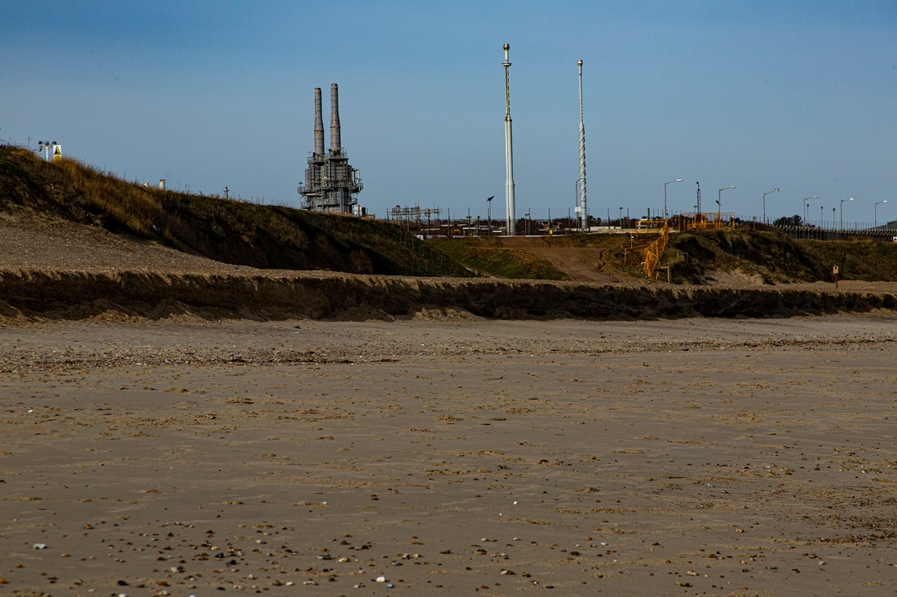

Hemsby, 5 miles south of Happisburgh so observe advanced erosion

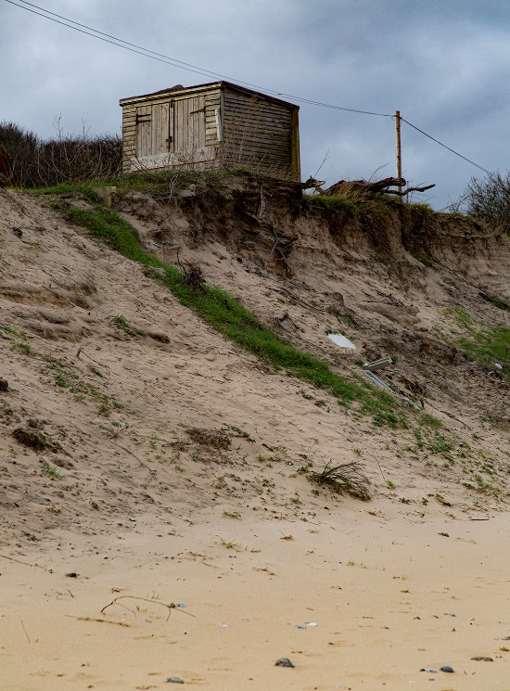

March – Aug Lockdown

12 Aug
Eureka Visit to Happisburgh to meet all the affected residents who are engaging with me. Great reception from all parties as well as a new (to the study) resident Sue whose bungalow is the most at risk and due for demolition. Rephotograph locals "in situ".
Oct 30
Revisit as break in lockdown
See Bryony building a large shed in rear of her garden. Her mood is somewhat sombre as the relative calm experienced over the last 9 months or so replaced by a major cliff fall including the ramp to the beach and she is aware that the small field she owns next to the ramp is in great danger of following the ramp. All the equipment she keeps in the field is being transferred to the new shed but a caravan will have to be disposed of as she has no room for it behind her property.

Light excellent so spend most of day on cliffs / beach – erosion along the cliff is worse I have seen since starting project.

