Alan D Horn 515733
Photography 3 Body of Work
Research Point
Gregory Crewdson (b.1962)

Gregory Crewdson is a photographer who operates with strong directional control in his image-making. His photographs function like film stills to the point where there is arguably not much reality left in the scene.
Do some research into Crewdson's work and in your learning log or blog reflect on how his work relates to film and/or art.

Crewdson's work concentrates on the dark side of "Small Town America" and involves meticulous staging where he invokes the sort of drama associated with sci fi or horror films and at times he produces images that are almost macabre.
I have examined his work from his "Early Period" through to 2005 using the publication – Gregory Crewdson (1985-2005)
Early Period (1986-1988)
There is no joy in his images. Empty rooms seemingly suggesting empty lives. One room with two suitcases and only one pair of (men's) shoes suggests that one person is leaving the home for good.
The gardens show no sign of life, a dinner place is set for one person and the females are resigned – expressionless.
Lighting is used to lead the eye – a story in every image.
Natural Wonder (1992-1997)
I can't in anyway say that this period gives me any form of pleasure or enthusiasm to analyse his methodology and message(s).
Using stuffed birds and animals he certainly demonstrates meticulous planning to create the images but they leave me cold.
Stephen Berg who is a contributor to the book also found this period confusing. In his summary of one of the images of five birds observing a large circle of about twenty eggs he comments that the perfect symmetry of the circle (which it is not!) is probably a metaphor for something but he found it "inexplicable". What is even more confusing than the comment is that Crewdson has never explained the image. Enough said!
Hover (1996-1997)
As the title suggests Crewdson hovers above his subjects using a truck-based hoist as if on a film set. All the images are black and white and the majority are staged dramas – house fires, a bear breaking into trash cans, police cars and bemused lookers on – all taking place in suburban streets. However, one image is (to me) highly amusing and a great construction – it is a street scene where a neighbour has extended his lawn, by laying turf from his existing lawn, across the pavement and road – even using a sprinkler. He is oblivious of his neighbours who look on totally bemused and of course there is the eponymous police car in the background - I doubt he meant it to be amusing.
Twilight (1998-2002)
The images evoke Sci Fi or even horror movies. Light beams on the subjects from a variety of sources which can be natural in the case of street lights, naked bulbs or car headlights or totally unnatural where beams appear from the sky to create an almost alien created feel to the image.
Subjects are drawn into the light source where a mystery seems to be about to be discovered.
Dream House (2002)
The underlying theme is one of menace and we start to see recurring scenarios from earlier work.
The theme of garden turf being used in a bizarre manner was initially seen in Hover and revisited in Twilight where dead birds (another revisit) were discovered beneath the turf in the lounge. Again, in Dream House, the same theme continues but this time in a garage with light coming (again) from car headlights.
This series gets even closer to his mimicking film stills and he uses top quality actors to take part in the series. Julienne Moore, Tilda Swinton and William Macy amongst others
Beneath the Roses (2003-2005)
The themes of hopelessness, sadness and loneliness continue and each image creates a story in itself.
Car doors open – are they leaving the car or about to get in?
Suitcases (again) - are they being packed or unpacked or do they contain some macabre evidence?
Bedrooms scenes that only create a coldness
Nakedness or partial undress that demonstrate no sexual desire or warmth – only indifference.

Whilst I see influences from a selection of directors including Hitchcock (Birds), Spielberg (Close Encounters) the greater influence to me is the painter, Edward Hopper (1882-1967).
His Nighthawks is reflected in the hopelessness of Crewdson's subjects, Rooms by the Sea (1951) and New York Movie (1939) are examples of light focussing on a subject be it a person standing alone to emphasise loneliness or changing the simplicity of an inanimate object into a story.
Crewdson's untitled image (Image 1) from Beneath the Roses bears a striking resemblance to Hopper's Hotel Room (1931) (Image 2) albeit, Crewdson's is (naturally!) more macabre (with blood on the hand).

Image 1
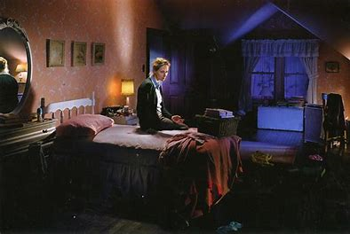
Image 2
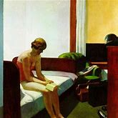
Image 3 – Hopper's Interior (Model Reading) (1925) also seems to show a number of similarities with Crewdson's images of females at a mirror – and note the suitcases that are also repeated in several Crewdson images.
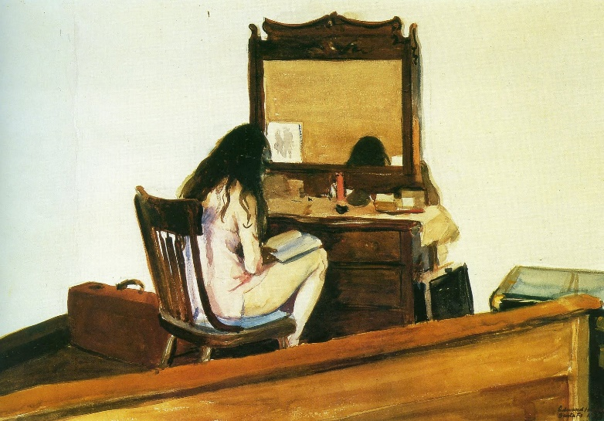

References
Gregory Crewdson (1985-2005) Hatje Cantz 2005
Various Hopper web sites

