Tutor Reports Observations, Recommendations, Actions

Body of Work

Tutor Andy Hughes

Assignment 1

Overall Comments
Images present a coherent start to module.
Clear line of thought
A visually strong initial sequence
Supporting text serves to add further information, giving images some connection…..

Assessment potential
Expect to achieve positive result

Feedback on Assignment
Images all focus on subject matter. Two in particular are stronger than others.
Consider how the topic might connect to other areas of interest such as ecology, environmentalism,
sustainability.

Coursework
Development of texts and research is a good start
Interviews provide a rich area of activity

Research
Reflectivity is clear in text. However, given the subject matter locate journals or way to develop a
deeper understanding of the systems of erosion.

Learning Log
Reflectivity is good but explore connection with other art forms such as |Dutch Landscapes and
Seascapes post 1600s

Actions
Study of Chris Killip work depicting entropy and erosion
Katie Paterson artworks on eroding coastline

Further thought process on way forward

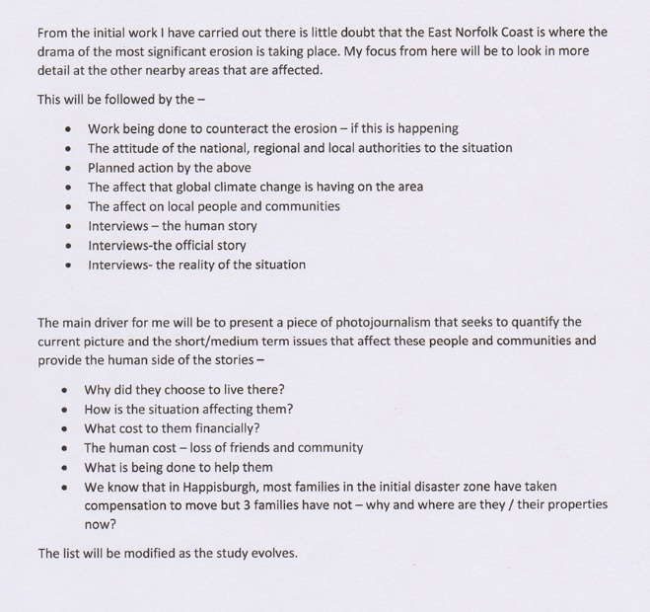

Assignment 2

Overall Comments
Clear that there is a developing sense of the relationship between factual information gathered via
interviews and field trips. Series holds together and has potential for development in combination
with further aesthetic consideration
Would like to see greater focus upon who else might be working on similar topics in the visual arts
more focussed on photographic practice.

Assessment Potential
Further focus needed on photographic practice

Feedback on Assignment
Conclusion is that "work is travelling in right direction". However needs to be more interesting /
illustrative.

I can see from comments that my images are boring and are a matter of fact with no "oomph". To be
fair, the light was poor but my evolving project was focussing on the factual story rather than telling
the story through the images.

Learning Log
Reflectivity is good in terms of capacity to find data and key people to work with from the
community. How can these relationships become explicit?

This is a fundamental observation that I took some time to realise/ come to terms with – the issue of
the key people is fundamental in the work. It leads to a documentary approach. They are as much a
part of the paper as the imagery of the erosion itself.

Suggested Reading

Jem Southam- Rockfalls
This is great work and shows that a "boring" and potentially repetitive subject can be dramatic. Enjoy
the fact that portrait orientation to emphasise height is used.
Also studied John Ganis – America's Endangered Coasts.
Areas for Development
Create a map of walking or photo route

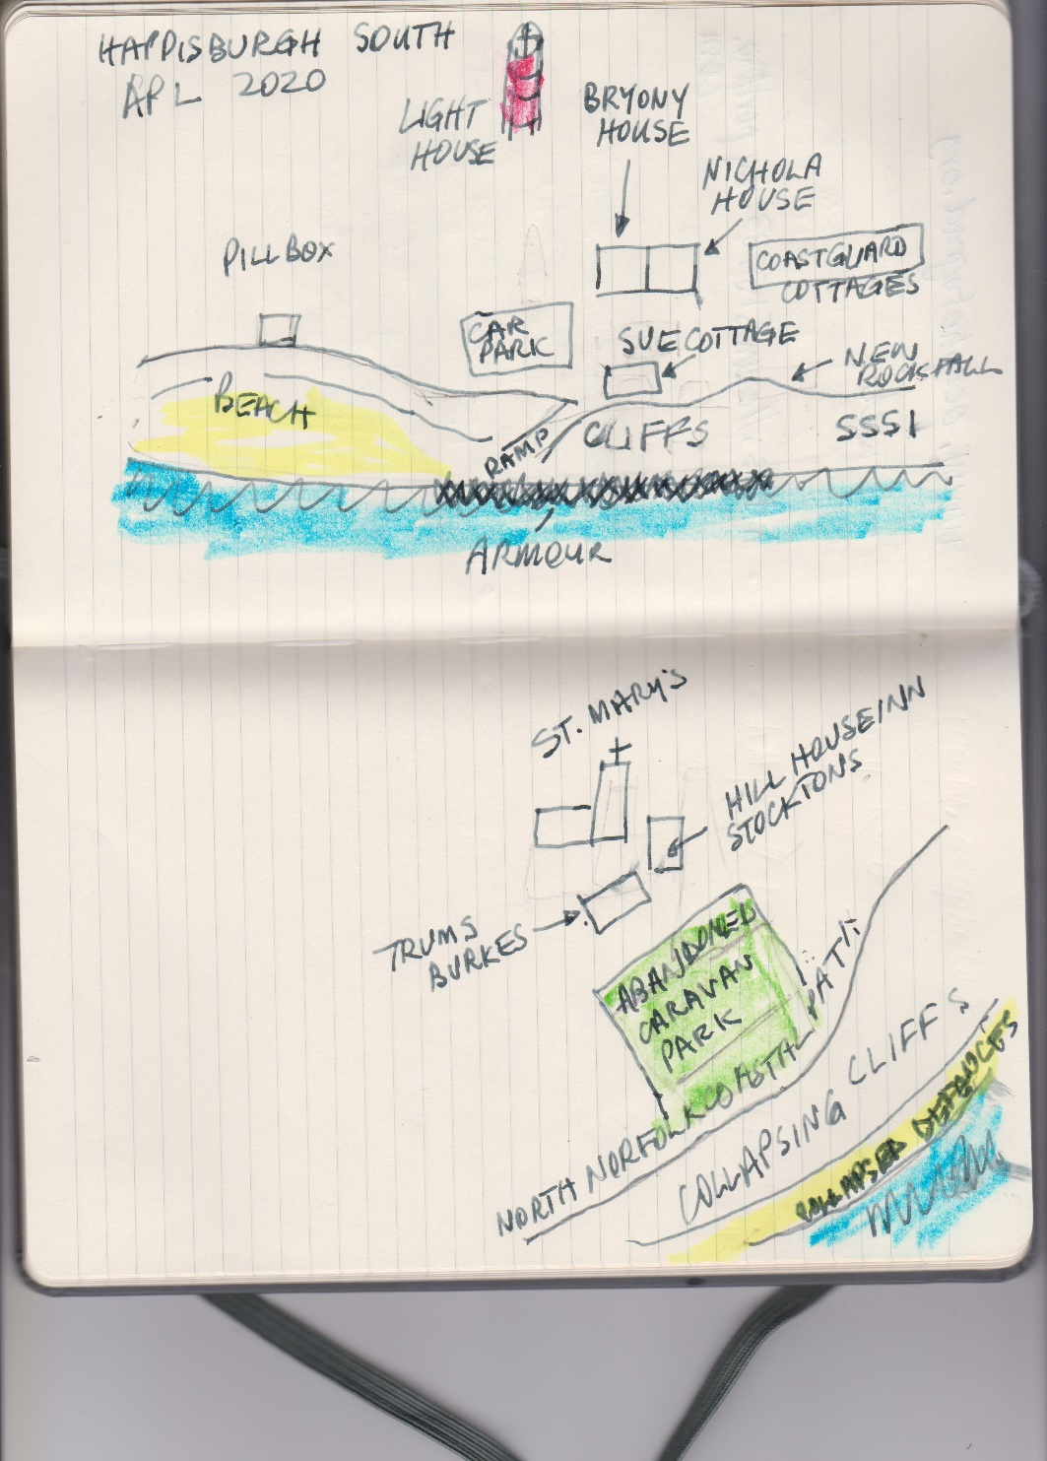

Assignment 3

Consisted of image comparisons between my own images compared to tutor recommended study.
Jem Southam / Jane Wilson / Chris Killip / Kate Paterson
Start of interview images plus text
Tutor questioned quality of portrait images but explained that these were very hurried as I needed
to see how they worked. The concept did and were re taken later. Tutor suggested that the texts
could have more impact if included as hand written text. Compromised (later) and got typed
comments from them.
Examples –

Katie Paterson - The Sound of Vatnajokull

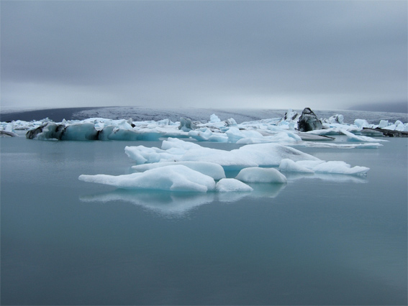

Alan D Horn Patagonian iceberg Jan 2019

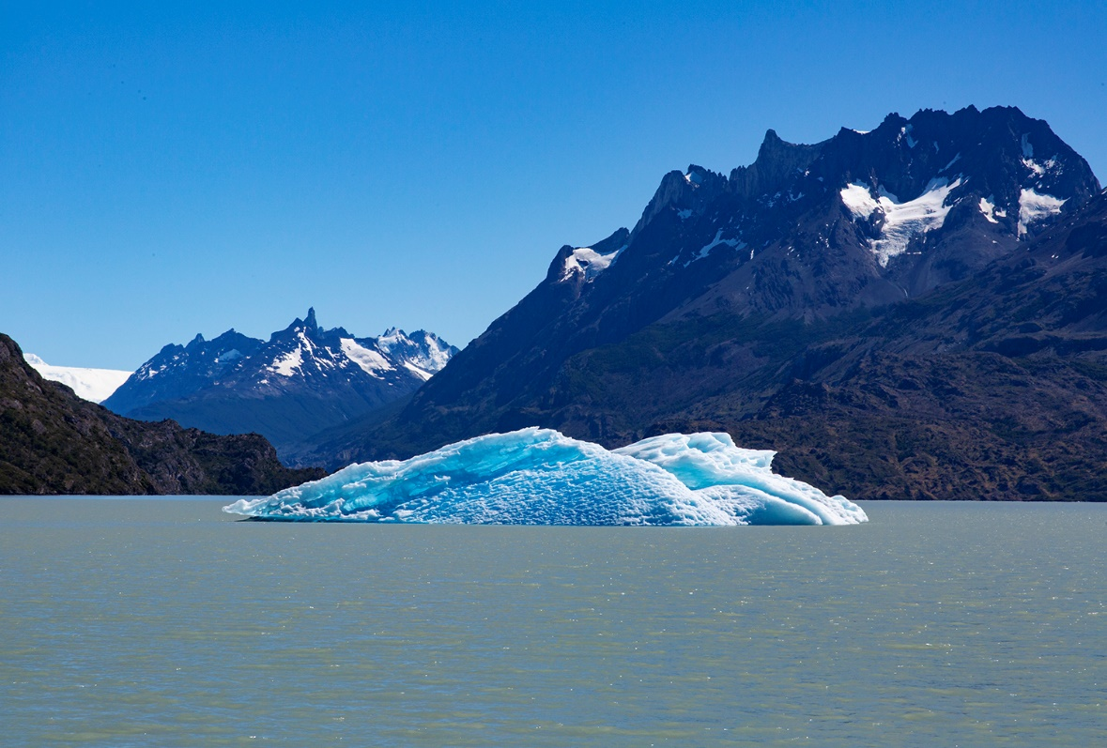

Katie's work also included the recordings of the sounds that icebergs make. My interest was more

the fact that the walk to the edge of the lake was 200mtrs across dry lake bed and 10 years ago, the
whole area was thick ice.
Assignment 4

1 Production of PowerPoint paper and virtual gallery

PowerPoint – within web site as Body of Work Assignment 4
https://www.alandhorn.co.uk/docs/Happisburgh%2023%20Sept.pdf

2 Virtual Gallery
Subject: Exhibition﻿
https://www.artsteps.com/view/5f7d798d07da063905ee707f

Overall Comments

Systematic approach to organising the work.
I can see the direct connection to the story about erosion
Strong sense of personal investment to you and the wider coastal community.
Might need further visual refinements for next phase

Feedback on Assignment

Really good to se the work in the virtual gallery space.
Possibly rethink the wording
Perhaps the images have within them expression without the need for title

Taken on board with final "book" draft

Images have visual integrity but can a connection be made with other disciplines such as geology or geography

Look at editing in areas of sequencing and design
How about texts from locals being hand written and photographed?

The "book" has been re-edited cutting out words due to clear sequencing. The commentary of the locals has also been redone. Tried hand written notes but unreadable so have included typed notes from them.

Strengths - Great use of VR to create online gallery
Further development and refinement of narrative elements

Areas for Development – Think about use of type, font and design of presentations
Try not to illustrate the images too directly
Design and aesthetics in layout

These are good points and I have addressed all of them with vigour.

Suggested Reading
Alec Soth Sleeping by the Mississippi
I also studied Niagara both pretty edgy but tell a story
Mark Power The Shipping Forecast
Assignment 5

Email exchange on final book with my actions

From: Andy Hughes
Sent: 18 December 2020 15:34
To: Alan Horn; Alan Horn; Tutor reports Send here
Subject: Alan-Horn- report5

Dear Alan

Hope your well and that xmas will be a good break from the current crisis we are all in.
I att your report, mostly I've concentrated on the final PDF as much of the previous commentary goes into some details about the whole of your BOW.

As long as you think further to make some adjustments then I think all would be fine for assessment.

Don't forget to also inform OCA if there are any mitigating health issues.

Keep well
Best for 2021.
Andy
Andy
Hi and thanks
I have taken all your views into consideration.
Main issues were
1 Background colour - this is now a pale grey
2 Typeface – yes agree and changed – it looks much better
3 Suggested layout – I have added pages to enable a less crowded appearance and kept the double page spread to one image plus text on opposing page, in the main.
4 Aesthetics – all type is H and V centred now with space around.
5 Images – with the extra pages I have been able to expand the size of the images to cover the page

I am going for assessment in Match and will undertake SYP starting now. I have asked if you will be my tutor – is this OK with you?

PS Thanks for the concerns on health. I am feeling pretty good now and last blood test / meeting with specialist was as good as I could have expected (PSA lower again at under 0.3). Fatigue is a minor issue now and I am back to circuit training (although a lot of this is on my own due to lockdown).
Hope all well with you.

Regards
Alan
Sent from Mail for Windows 10

